Car Crash Simulator 3000

by Hayden Schiff

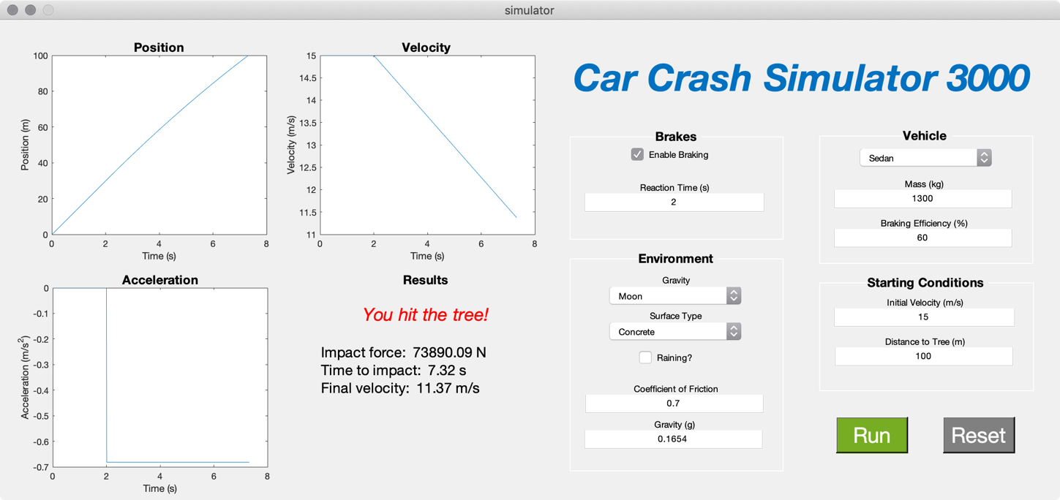

# Introduction

This is a GUI that simulates a car crashing into a tree. You can set all the parameters, including mass and braking power of the car, road surface, gravity, driver reaction time, starting velocity, and distance from tree. I chose this concept because I feel pretty confident in my knowledge of the underlying math. I also thought it’d be fun to play with the numbers and see what the limits are for each value.

# Concept

This GUI illustrates motion laws in physics. Specifically, it teaches you about position, velocity, and acceleration, as well as about gravity, coefficients of friction, and stopping distance. The GUI allows you to see the graphs of how position, velocity, and acceleration are related to each other. By re-running the simulation repeatedly with slightly altered numbers, one can easily see how gravity, road surface, and other factors affect the simulation.

# Usage

To use this GUI, you adjust all the values on the right half of the interface to your liking. There is no right or wrong way to set these values; appropriate values are best learned through experimentation. If you enter an invalid value, an error message will appear in the console and the field will revert to the default. Here is what each field means:

**Brakes**

* Enable Braking: Should the driver attempt to brake? (if you disable this, you are guaranteed to crash)
* Reaction Time: How long (in seconds) does it take for the driver to step on the brakes?

**Vehicle**

There are two ways to configure what type of vehicle you’re driving:

1. You can use a preset vehicle by selecting an option from the dropdown menu. This will auto-fill the text boxes.
2. You can manually configure a vehicle by editing the text boxes:
   1. Mass: The mass of the vehicle in kilograms
   2. Braking Efficiency: How effective your brakes are, as a percentage. This is calculated by dividing the braking force by the vehicle’s weight.

**Environment**

There are two ways to configure the environment in which the simulation takes place:

1. You can use the dropdown menu and checkbox to specify the environment:
   1. Gravity: The planet, moon, or other celestial body this simulation will take place on
   2. Surface Type: The material of the road, which will determine how much friction exists between the tires and the surface
   3. Raining?: Check this box to simulate a rainy day, which reduces the surface friction
2. You can manually configure the environment with the text boxes:
   1. Coefficient of Friction: A number between 0 and 1 which defines how rough this surface is. The brakes will be more effective the higher this number is.
   2. Gravity: The negative vertical acceleration due to gravity, in Gs (1G = 9.81m/s = gravity on Earth)

**Starting Conditions**

* Initial Velocity: How fast (in meters per second) is the vehicle moving at the start of the simulation?
* Distance to Tree: How far away (in meters) is the tree from the vehicle at the start of the simulation?

Once you are satisfied with the parameters, you can click the green “Run” button to run the simulation. This will cause the graphs and result fields on the left side to update and show you the result of the experiment.

After running the simulation, you should continue updating the parameters and running it again to see how your changes affect the results. If you would like to reset all the parameters to the original values, click the grey “Reset” button.

# Contributors

* Hayden Schiff: everything

# Challenges

One thing I had a lot of issues with was finding the braking efficiency values for real-world cars. Unfortunately, car manufacturers are not required to publish this information, so I had to hunt down scientific studies that others had done where they calculated these values.

I also found that implementing complex graphing functions was much more difficult than I expected. I had originally intended to implement simulated views of the crash in the graphing windows, but I quickly found that this was extremely difficult to do. I worked around this by replacing those graphs with position, velocity, and acceleration plots.

# Conclusion

Overall, I thought this was a really interesting project. I think this project could definitely be useful to a beginning physics student as they learn motion laws.

# References

* Surface friction coefficient values, braking formulas: <http://inform.wabco-auto.com/intl/pdf/815/00/57/8150100573-23.pdf>
* Tractor data:
  + Braking efficiency: <http://www.rsa.ie/Documents/Your%20Vehicle/Ag_vehicles/Braking_FAQs.pdf>
  + Weight: <http://www.tractordata.com/farm-tractors/005/7/9/5791-john-deere-5055e.html>
* Sedan data:
  + Braking efficiency: <https://mattersoftesting.blog.gov.uk/changes-made-to-brake-performance-test/>
  + Weight: <https://www.edmunds.com/toyota/corolla/2014/features-specs/>
* Truck data: <http://road-transport-technology.org/Proceedings/2%20-%20ISHVWD/Vol%201/ESTIMATED%20BRAKING%20EFFICIENCIES%20OF%20DIFFERENT%20ONTARIO%20TRUCK%20CONFIGURATIONS%20-%20Hutchinson%20.pdf>
* Gravity constants: <https://en.wikipedia.org/wiki/Surface_gravity#Relationship_of_surface_gravity_to_mass_and_radius>